The information and views set out in this publication are those of the authors and do not necessarily reflect the official opinion of the European Union. Neither the European Union institutions and bodies nor any person acting on their behalf may be held responsible for the use which may be made of the information contained therein.
Erasmus+ KA2 Knowledge Alliances project
“Greening Energy Market and Finance - GrEnFIn”
AGREEMENT NUMBER: 612408
PROJECT NUMBER: 612408 – EPP-1-2019-1-EPPKA2-KA

WP10 – D10.1
Final reports concerning the internal evaluation of the results
Evaluation Report of Project Meeting 8, M36

Work Package (WP) | WP10 Quality & Evaluation plan
WP Leader | WU
Deliverable Title and Number | WP10 – D10.1  Final reports concerning the internal evaluation of the results  Evaluation Report of Project Meeting 8, M36
Release date | October 2022 - M36
Version | 1
Dissemination Level | Confidential
Author | WU – Régis Gourdel
Main Contributors
Revised and Approved by | UNIBO, MIWenergia, SPEED

INDEX
1. Analysis of the respondent profiles 3
2. Evaluation of the first day 3
3. Evaluation of the second day 4
4. Evaluation of the partners’ feedback 4
5. KPI evaluation 6
6. Conclusion 6

Executive Summary

The eighth Project Meeting of GrEnFIn took place on the 20th and 21st of October 2022. It was organised in the form of a final conference that would provide a conclusion to the project as a whole. The meeting took place at the University of Bologna. The morning of the first day was dedicated to the main outcomes (the GrEnFIn Master, the Professional Module and the online Platform). In the afternoon, the speakers presented the transversal outcomes such as management, evaluation, dissemination and sustainability. On the second day, the morning was dedicated to the academic presentations of different professors and partners. In the afternoon, the Conference continued with Prof. Tankov’s Lectio Magistralis. This deliverable builds on the evaluation of three separate questionnaires: one for each day of the conference, and a last one dedicated to project partners, with questions similar to that of previous meetings.

Analysis of the respondent profiles

This first section analyses the information regarding the respondents profiles, which was gathered during the initial registration form for both days, as well as in the daily questionnaires. This information is meant for us to understand the profile of respondents in the sample.

A total of 82 people filled the registration form, 46 of them registered for both days, 30 only for the second day, and 6 only for the first day. A total of 25 registered to be online. Setting aside the organizer of the events within the consortium as well as the external evaluator, the large majority (66) of registered people attended following a direct invitation. Six people registered because they were informed about the event through the GrEnFIn website and four through social media.

In the “daily” questionnaires, the first question concerns the respondents’ main activity, with results given in figure 1. We note that for both days there was a strong part of academic personal from partner HEIs and private sector professionals. On the second day, there were also 8 students from partner universities among respondents. Other categories had at most one respondent.
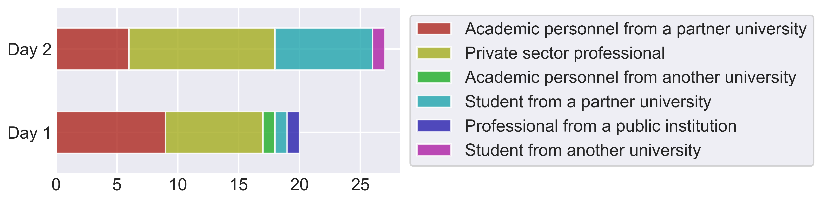Figure 1: Employment of respondents
Second, respondents were asked about their main field of work or interest, with different options available (no respondent used the “other” option). We see that the biggest group of respondents is that of people working in financial mathematics and risk management. It is followed by “energy and energy economics” (for day 1) and “sustainable finance” (for day 2).

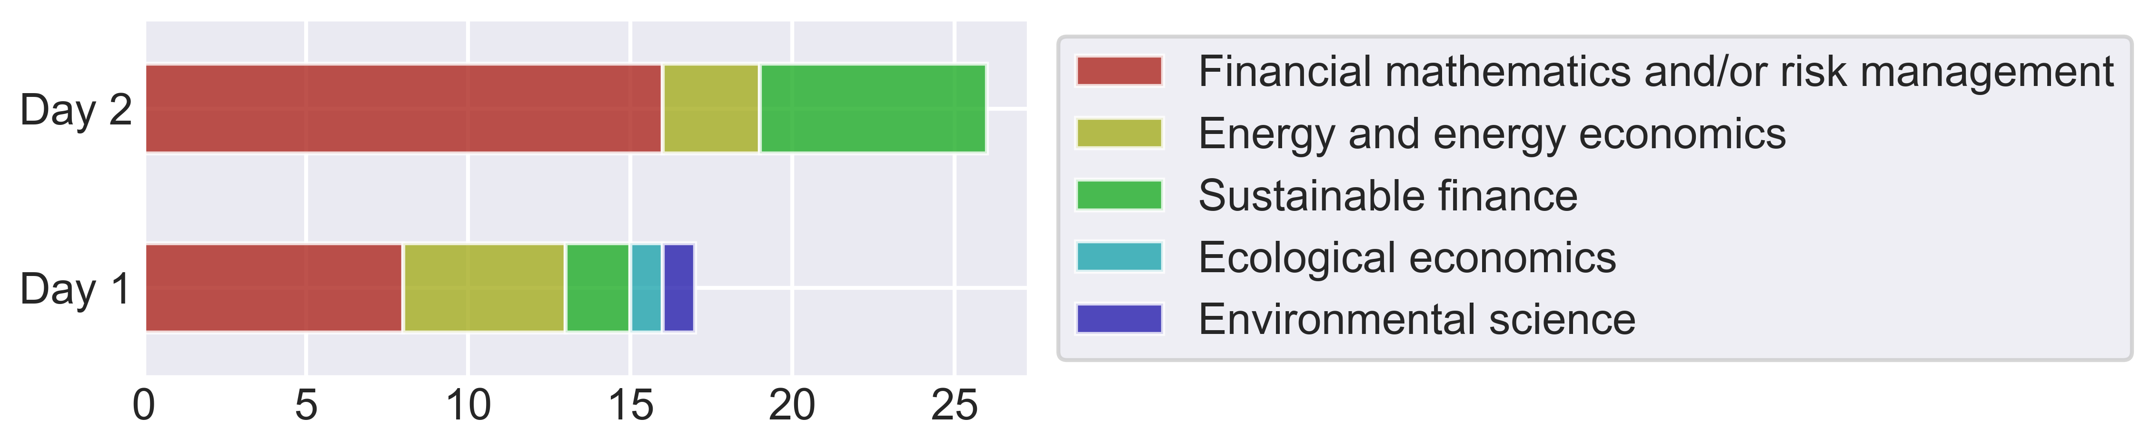Figure 2: Field of work or study of respondents
It is worth noticing that the second day attracted more attendants external to the consortium, as there was only a small overlap between both days: from the 27 respondents of the second day, just 10 were present the first day.

Evaluation of the first day

We focus now on the feedback collected relative to the first day of the meeting, where presentations related to the different WPs of the project took place. This questionnaire received 20 responses in total.
Other than the questions treated above, for the first day specifically, we identify the primary interest of the respondent, between the Master and the professional training programme. In the sample, 11 respondents had more interest in the Master, and the other 9 in the professional programme.

A first set of questions (whose results could not be fully analysed due to technical issues) asked users about their perception of the event and their interest for different aspects of the GrEnFIn project. The three questions assessed received a mean rating over 4.6, which denotes a general satisfaction and interest of respondents. Although a few ratings given were below 4, the comments left by respondents are all positive and do not provide further explanation for this.

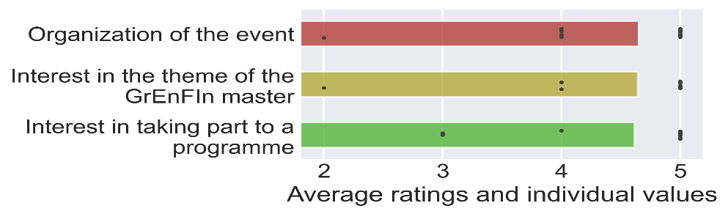
Figure 3: Feedback and interest from respondents
When asked whether their company or institution would be interested in the services of a Sustainable Energy Expert, 12 respondent answered yes, while the question was not applicable to the rest. Thus, the final view in terms of employability of the SEE is very positive.

Finally, participants were asked whether their company or institution already has a dedicated department aimed to manage the energy transition. There were 10 respondents answering by yes, 5 by no, and the rest indicated that the question was not applicable.

Evaluation of the second day

For the second day, 27 respondents filled the dedicated survey. A general question with regard to the organisation was asked. We obtained an average rating of 4.3, which is lower than that of the first day but still satisfying. Results are presented in figure 4.

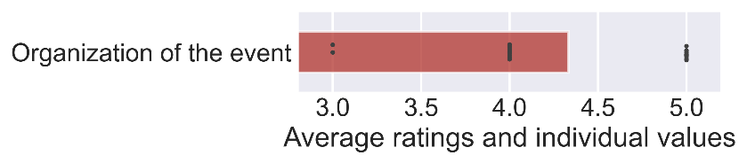
Figure 4: Respondents' perception of the organization for day 2

On the planning of the day, we asked participants about the time allocation of the day, with the option to say whether certain parts where too short, the right length, or too long. Results are presented in figure 5. From mapping these values to a scale from 1 to 3, we also computed the averages of each. The parts looked at were the length of the presentations, the time given for discussion and Q&A, and the time for networking. On all three, the majority of respondents found that the time allocated was right. The largest deviation was on the time allocated for networking and exchange, where several respondents found it too short.

The comments were mostly positive, although one respondent mentioned that the online presentations were difficult to follow.
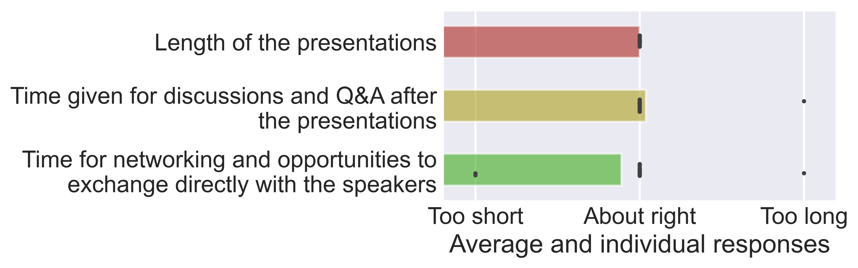Figure 5: Responses on the time allocation of the second day

Evaluation of the partners’ feedback

This last edition of the project meeting allowed us to get responses from sixteen participants, coming from 12 different consortium partners. The questionnaire was divided in three parts, the first one on the logistics, the second on the structure and the last one for general comments. All three show a general satisfaction of partners, through the ratings and through positive appraisal of the event in comments (see table in appendix).

The questions on logistics and structure were all quantitatively assessed by asking participants to assign a grade between 1 and 5 to the different aspects, where 1 means that the item was not satisfying and 5 that it was completely satisfying. The feedback from questions on the logistics (figure 6) is overall good, with the lowest receiving an average over 4.6. This is in line with previous surveys.
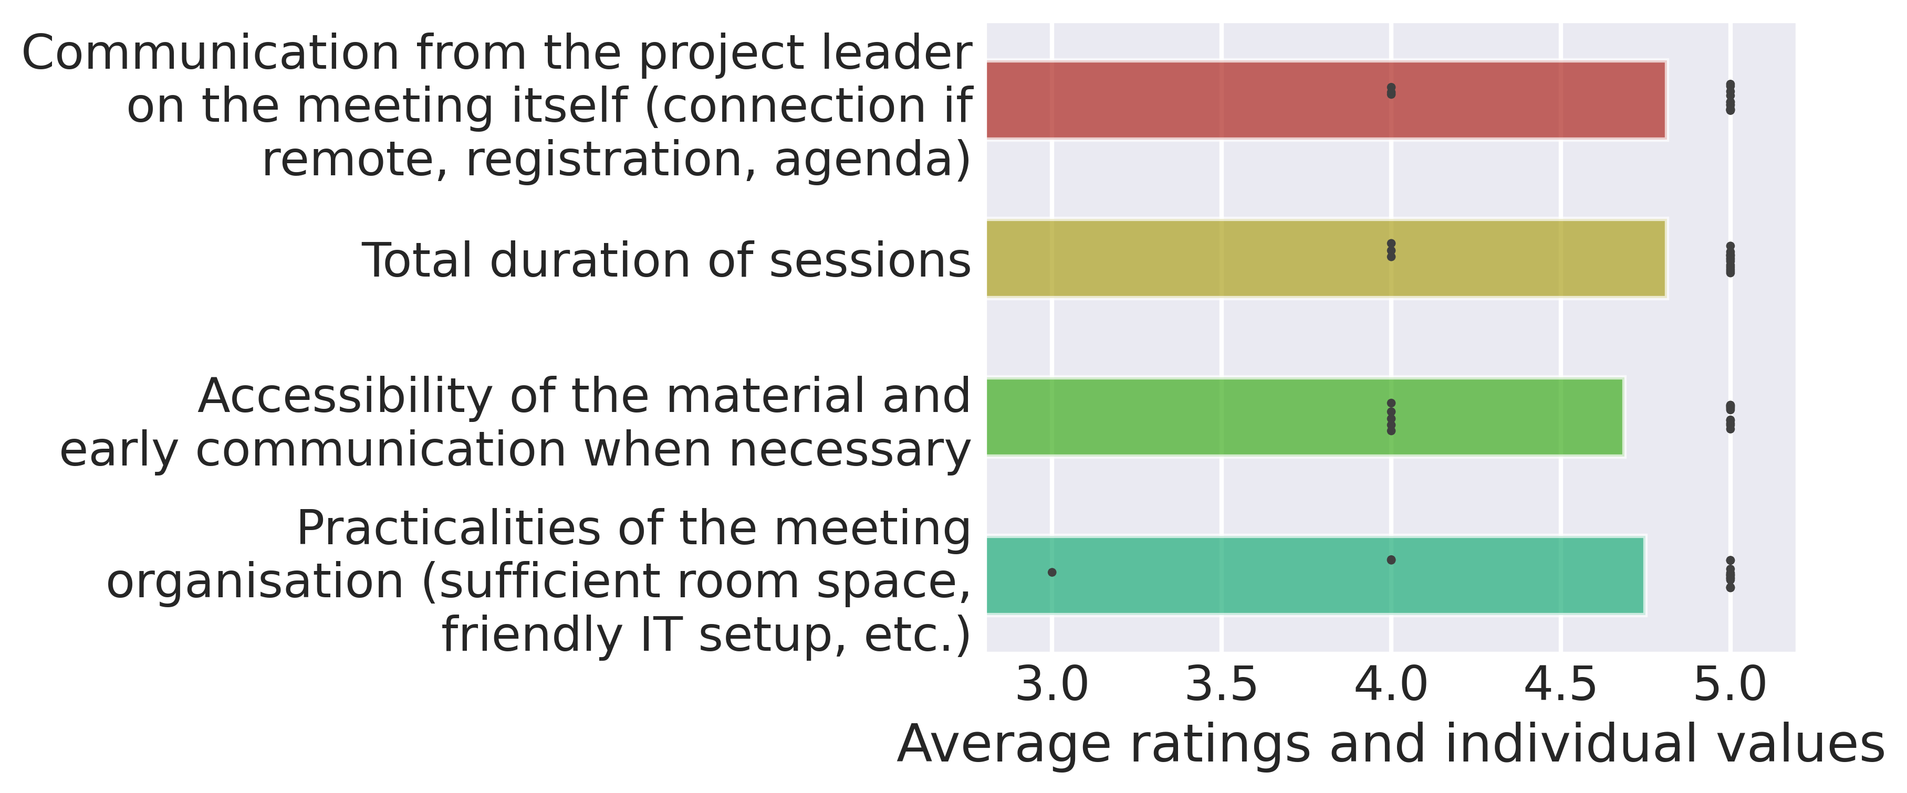Figure 6: Ratings given to aspects relative to the logistics

As with previous meetings, some of the grades given on the meeting structure (figure 7) are a bit lower than for logistics. For this meeting, the point falling short of the others is “Discussion of new issues emerged”, which would be reflective of the “final wrap up” nature of the meeting, which was not organised with the idea of opening new discussions in the sessions. To balance this, the time given to core project discussions was very positively assessed.
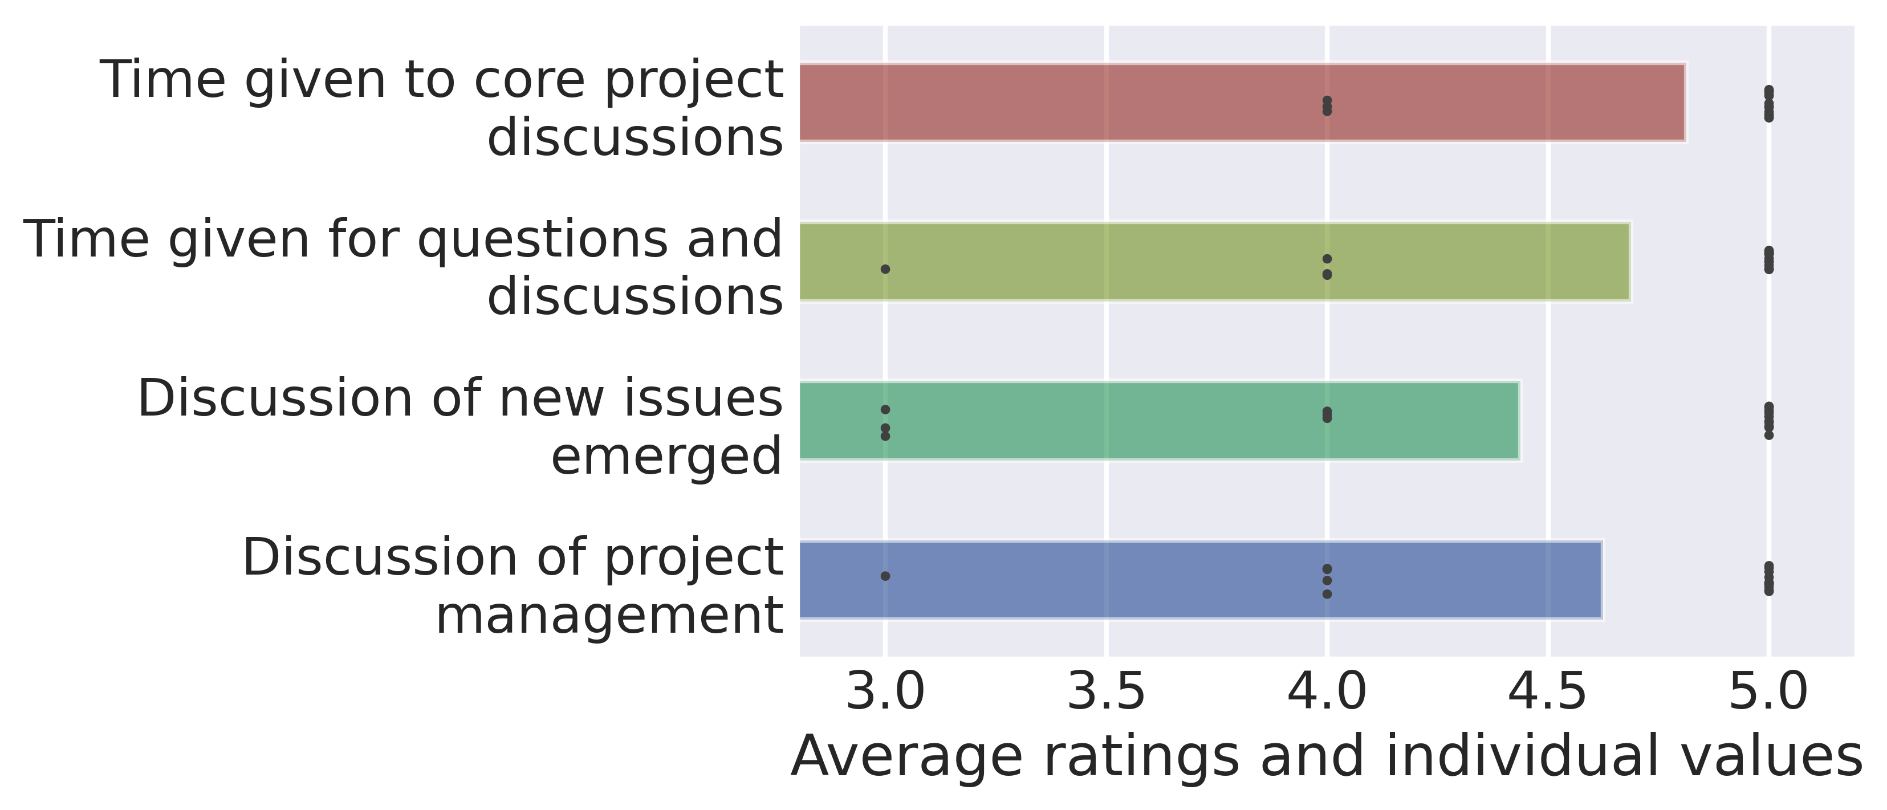Figure 7: Ratings given to aspects related to the structure, on a scale from 1 to 5

KPI evaluation

Number | Title | Evaluation | Comments
PI 0.2 | Number of questionnaires submitted | 37 | We are counting here the number of unique respondents, and not the number of questionnaires, with the assumption that all partners who filled their specific questionnaire were attending one of the two days.
PI 0.3 | Response rate | 66%
PI 0.5 | Appreciation/  satisfaction rate | 94% | We isolate the responses about the organization of the event, concatenating those of the two days, and consider that ratings from 1 to 3 express dissatisfaction.
PI 0.7 | Number of attendants | 56 | This is the total of all unique participants who attended at least one of the two days
PI 10.2 | Final reports drafted at the end of every project meeting | Satisfied

Conclusion

The meeting appears to have been satisfying in terms of both the attendance and the satisfaction of respondents. The analysis of questionnaires was limited by technical issues in the collection and storage of responses, so that not all responses given could be reflected in this evaluation. Though the response rate was lower than usual, we believe that this is in part a consequence of the format, which makes it difficult to communicate the form to all. That is especially the case as some participants only attended part of some days. We observe in particular that the total number of participants was high, and the large majority of comments given were positive. Therefore, the meeting makes up for a successful conclusion of the project.

Appendix: full written comments

Comments on the first day
The Master’s programme is well designed and gives a wide perspective to students by having the possibility to benefit from the expertise of three major European projects. The event is very well organized. Thank you for UNIBO for hosting us.
Well organised
The session was a good summary of the project work and explained the tasks performed without going too deep into details in order to keep a good rythm on the different sections
Very well organized
Very good and important project !!!
Everything was fine
Very good organisation. Good programme let participant get an overview of the project.

Comments on the second day
Very interesting
It was a little bit difficult to follow online presentations
Wonderful topics and speakers.

Comments from partners
- The physical meeting was again a great succes due to the great involvement of all partners. I believe we took good advantage of this final gathering to share the results of our project and continue the discussion about further collaborations beyond the project.
- Everything was well done.
- All perfect, it has been a pleasure to attend!
- I was unable to attend the conference in person due to illness, however, Viola, Giulia and Silvia were very accommodating and helped me attending the conference online. The conference was organised beautifully. It was a great way to close an amazing project
- Great hospitality, nice to see all!
- Everything was fine
- W

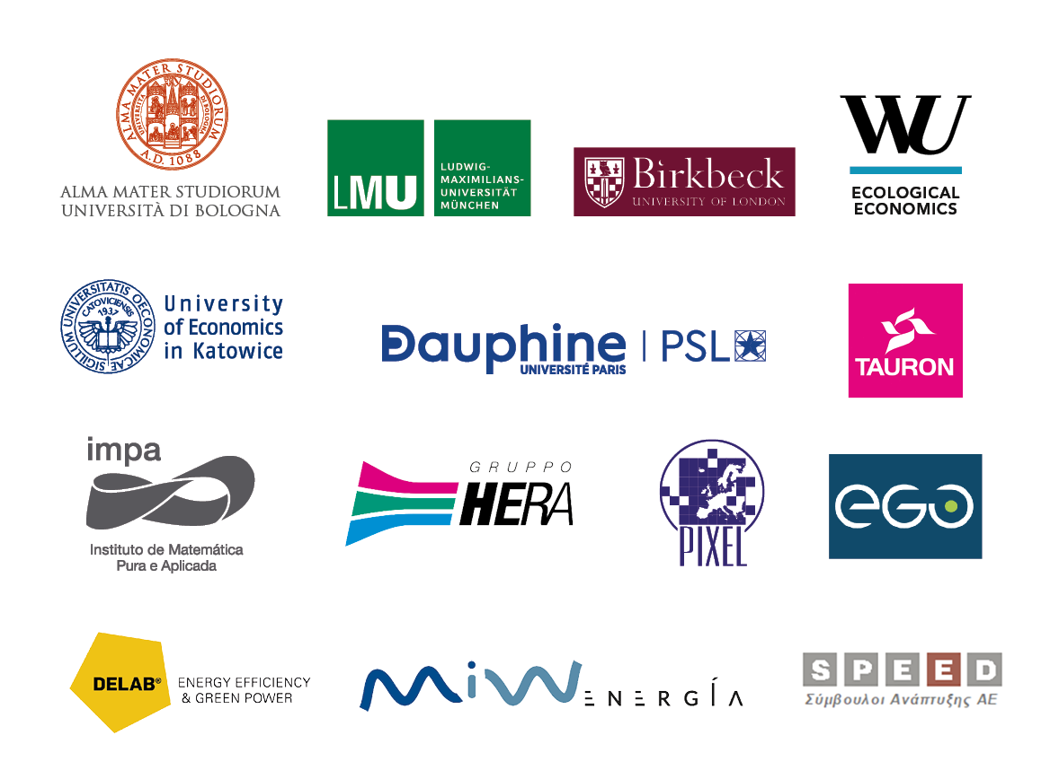
The questionnaire proposed in this edition was somewhat updated compared to the previous online project meetings from July 2021 and March 2022. The response rate was still very satisfying, even if the total number of participants was a bit smaller. The quantitative and qualitative feedback received has been clearly positive overall, even showing an improvement across all categories. The switch to hybrid seems to have been smooth, and no logistic issue appears from the evaluation.

